AWS Automation with Lambda & Boto3
_____________________________________________________________________________________________________
4.Daily AWS Cost Alert Using Cost Explorer API and SNS (Production-Ready)
Objective
Create an automated AWS cost monitoring solution that:
- Retrieves Month-to-Date (MTD) AWS spend using the AWS Cost Explorer API
- Compares the spend against a configurable threshold
- Sends an email notification through Amazon SNS when the threshold is exceeded
- Runs automatically every day using Amazon EventBridge

Step 1 – Enable AWS Cost Explorer
- Login to AWS Console.
- Open Billing and Cost Management.
- Select Cost Explorer.
- Click Enable Cost Explorer.
Note: Cost Explorer may take up to 24 hours before cost data becomes available.

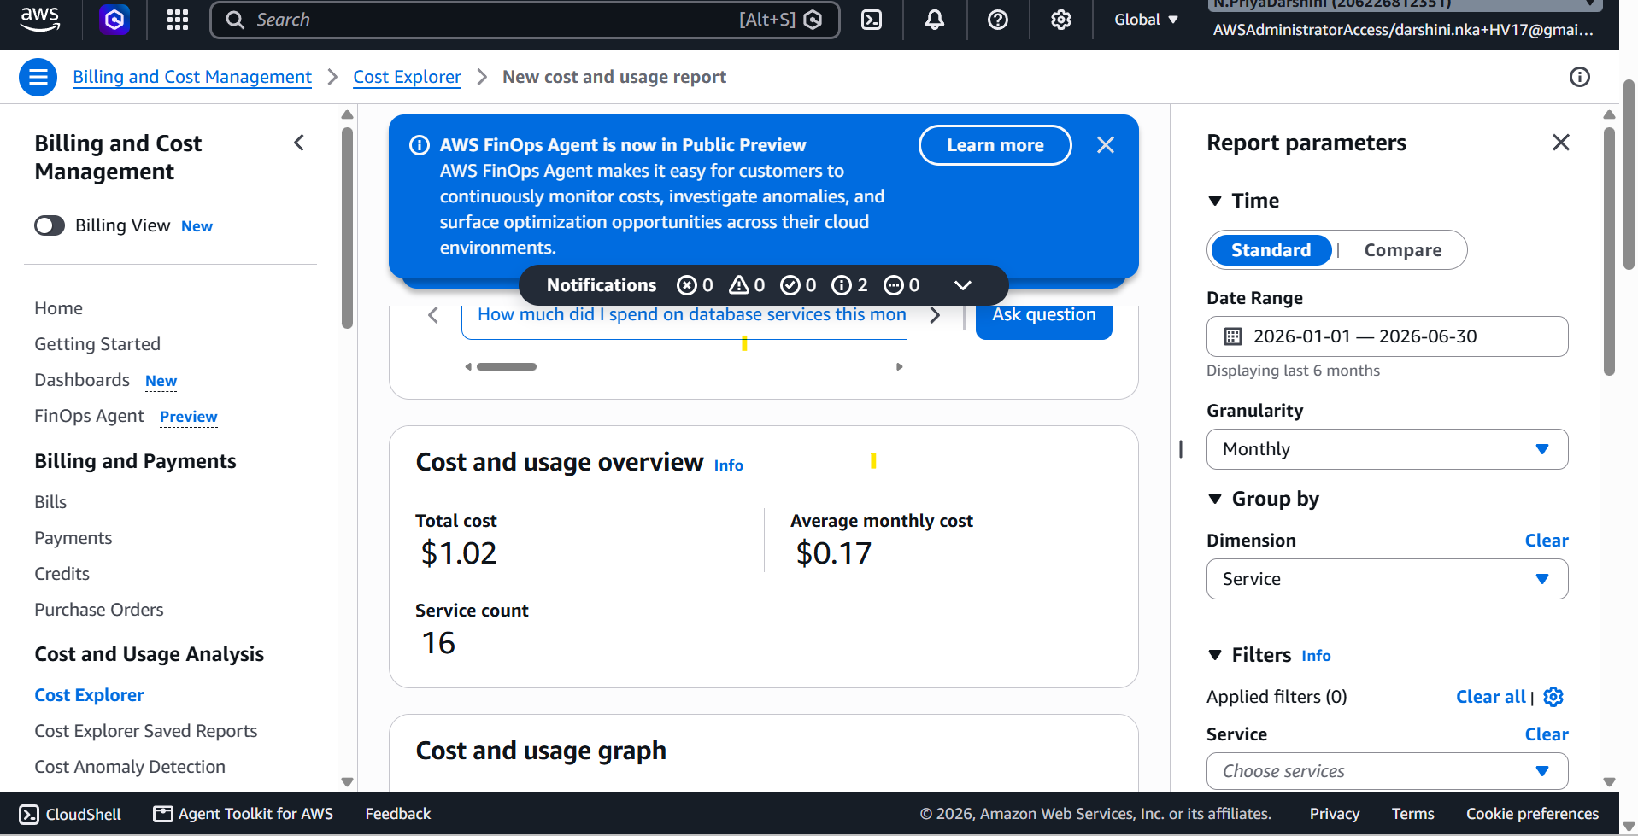

Step 2 – Create an SNS Topic
Navigate to:
Amazon SNS
→ Topics
→ Create Topic
Choose:
- Type: Standard
- Name: Costexplorer-SNS
Example ARN:
arn:aws:sns:us-east-1:206226812351:Costexplorer-SNS

Step 3 – Subscribe Your Email
Open the topic.
Click
Create Subscription
Select
Protocol: Email
Enter your email address.
Click
Create Subscription
Open your email and click Confirm Subscription.
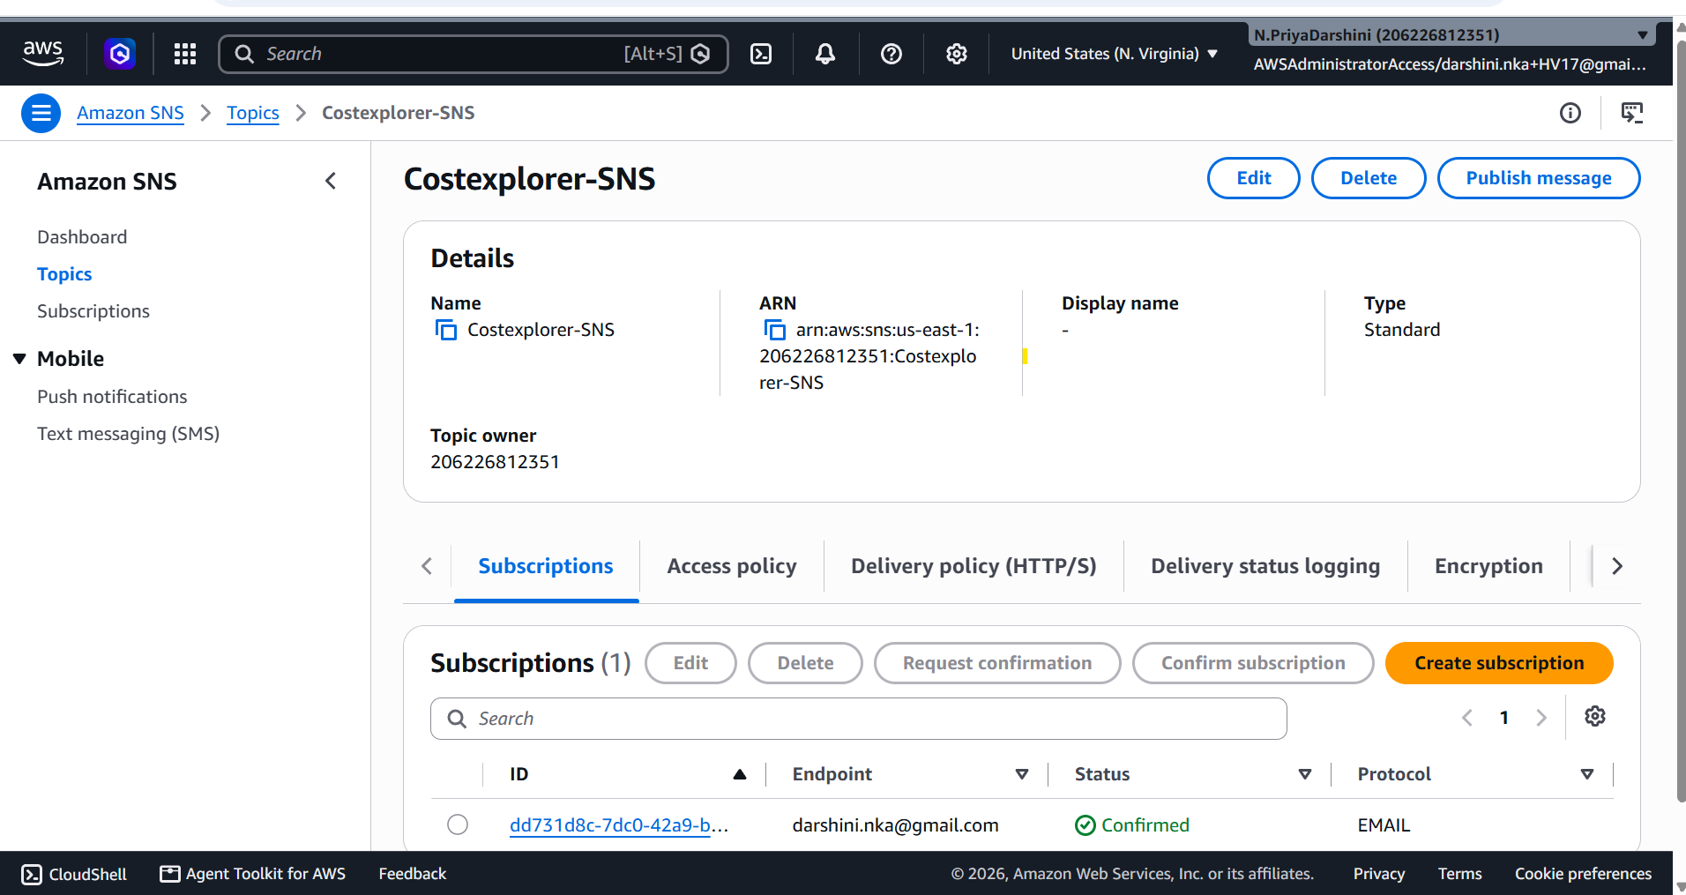

Step 4 – Create IAM Role
Navigate to
IAM
→ Roles
→ Create Role
Trusted Entity
AWS Service
Use Case
Lambda
Role Name
CostExplorerLambdaRole

Step 5 – Attach CloudWatch Policy
Attach the managed policy
AWSLambdaBasicExecutionRole

Step 6 – Create Inline IAM Policy
Replace the SNS ARN with your own.
{
"Version": "2012-10-17",
"Statement": [
{
"Sid": "CostExplorerAccess",
"Effect": "Allow",
"Action": [
"ce:GetCostAndUsage"
],
"Resource": "*"
},
{
"Sid": "SNSPublishPermission",
"Effect": "Allow",
"Action": [
"sns:Publish"
],
"Resource": "arn:aws:sns:us-east-1:123456789012:DailyCostAlertTopic"
}
]
}

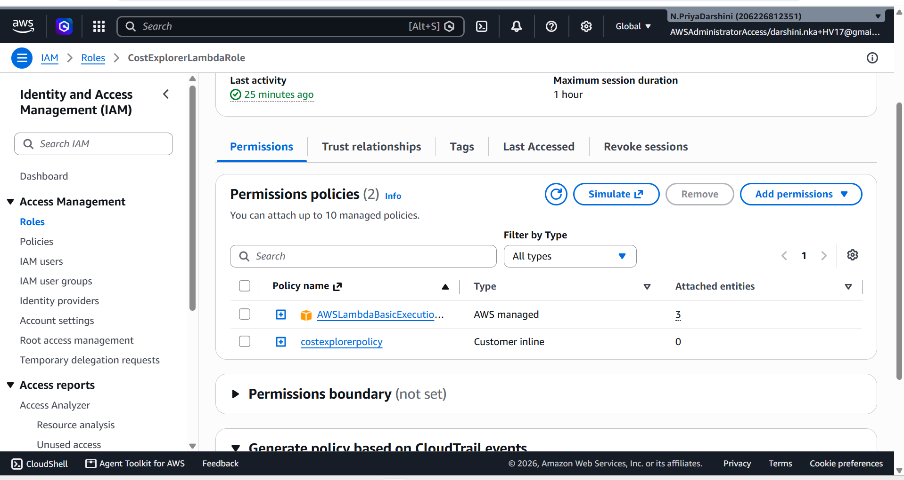

Step 7 – Create Lambda Function
Navigate to
Lambda
→ Create Function
Configuration
Setting | Value
Name | DailyCostAlert
Runtime | Python 3.12
Architecture | x86_64
Execution Role | CostExplorerLambdaRole
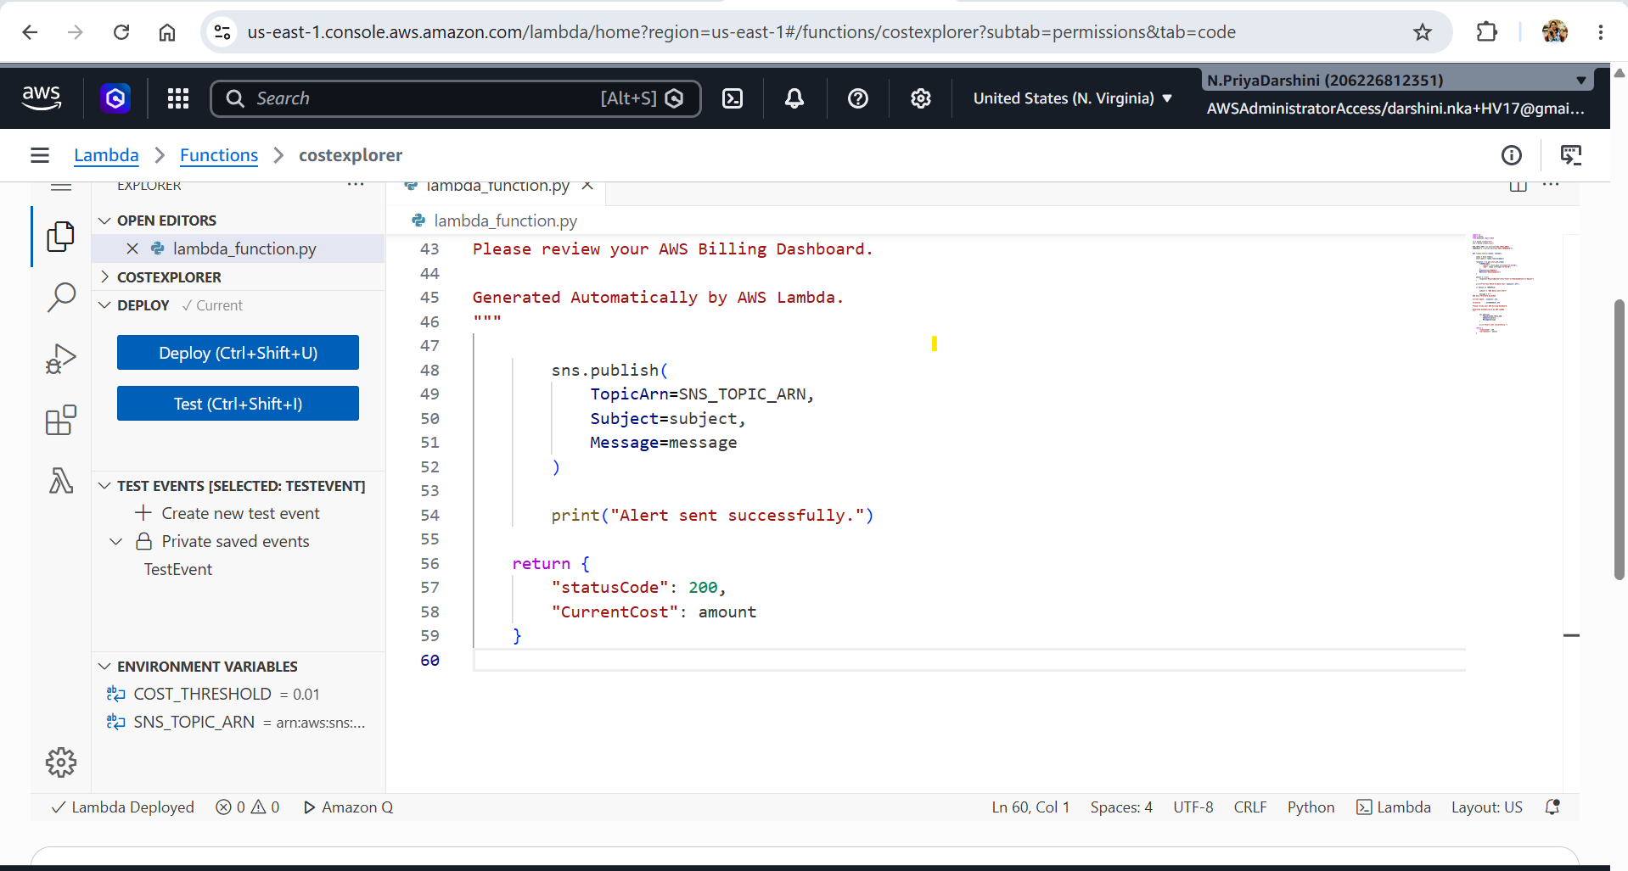

Step 8 – Configure Environment Variables (Best Practice)
Instead of hardcoding values, configure the following environment variables in the Lambda function:
Variable | Example
SNS_TOPIC_ARN | arn:aws:sns:us-east-1:123456789012:DailyCostAlertTopic
COST_THRESHOLD | 50
For testing:
COST_THRESHOLD=0.01
For production:
COST_THRESHOLD=50 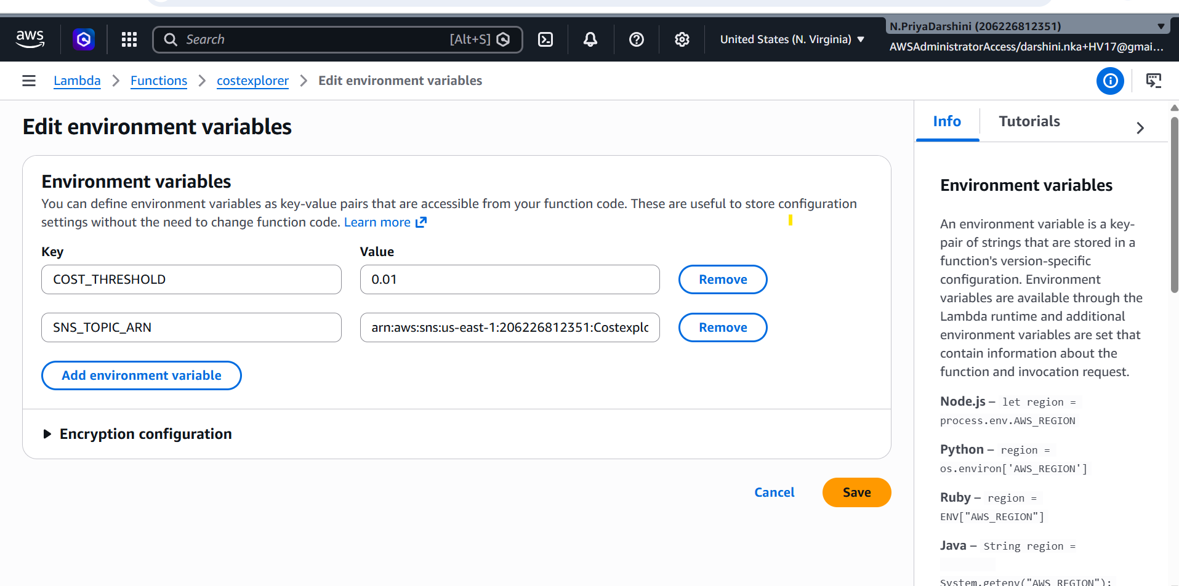

Step 9 – Lambda Code (Production-Ready)
import os
import boto3
from datetime import date

ce = boto3.client("ce")
sns = boto3.client("sns")

SNS_TOPIC_ARN = os.environ["SNS_TOPIC_ARN"]
THRESHOLD = float(os.environ["COST_THRESHOLD"])

def lambda_handler(event, context):

today = date.today()
start_date = today.replace(day=1)

response = ce.get_cost_and_usage(
TimePeriod={
"Start": start_date.strftime("%Y-%m-%d"),
"End": today.strftime("%Y-%m-%d")
},
Granularity="MONTHLY",
Metrics=["UnblendedCost"]
)

amount = float(
response["ResultsByTime"][0]["Total"]["UnblendedCost"]["Amount"]
)

print(f"Current Month-to-Date Cost: ${amount:.2f}")

if amount >= THRESHOLD:

subject = "AWS Daily Cost Alert"

message = f"""
AWS Cost Threshold Exceeded

Current Spend : ${amount:.2f}

Threshold : ${THRESHOLD:.2f}

Please review your AWS Billing Dashboard.

Generated Automatically by AWS Lambda.
"""

sns.publish(
TopicArn=SNS_TOPIC_ARN,
Subject=subject,
Message=message
)

print("Alert sent successfully.")

return {
"statusCode": 200,
"CurrentCost": amount
}

Step 10 – Deploy Lambda
Click
Deploy

Step 11 – Test the Function
Create a test event:
{}
Set the threshold to:
0.01
Run the Lambda.

----------------------------------
Expected output:

Status: Succeeded
Test Event Name: TestEvent

Response:
{
"statusCode": 200,
"CurrentCost": 7.7283596454
}

The area below shows the last 4 KB of the execution log.

Function Logs:
START RequestId: 9d5c8ba7-5a00-404f-be36-32618c8ede5f Version: $LATEST
Current Month-to-Date Cost: $7.73
Alert sent successfully.
END RequestId: 9d5c8ba7-5a00-404f-be36-32618c8ede5f
REPORT RequestId: 9d5c8ba7-5a00-404f-be36-32618c8ede5f Duration: 730.83 ms Billed Duration: 1207 ms Memory Size: 128 MB Max Memory Used: 94 MB Init Duration: 475.40 ms

Request ID: 9d5c8ba7-5a00-404f-be36-32618c8ede5f

-------------------------------

Alert sent successfully.
You should receive an email from Amazon SNS.

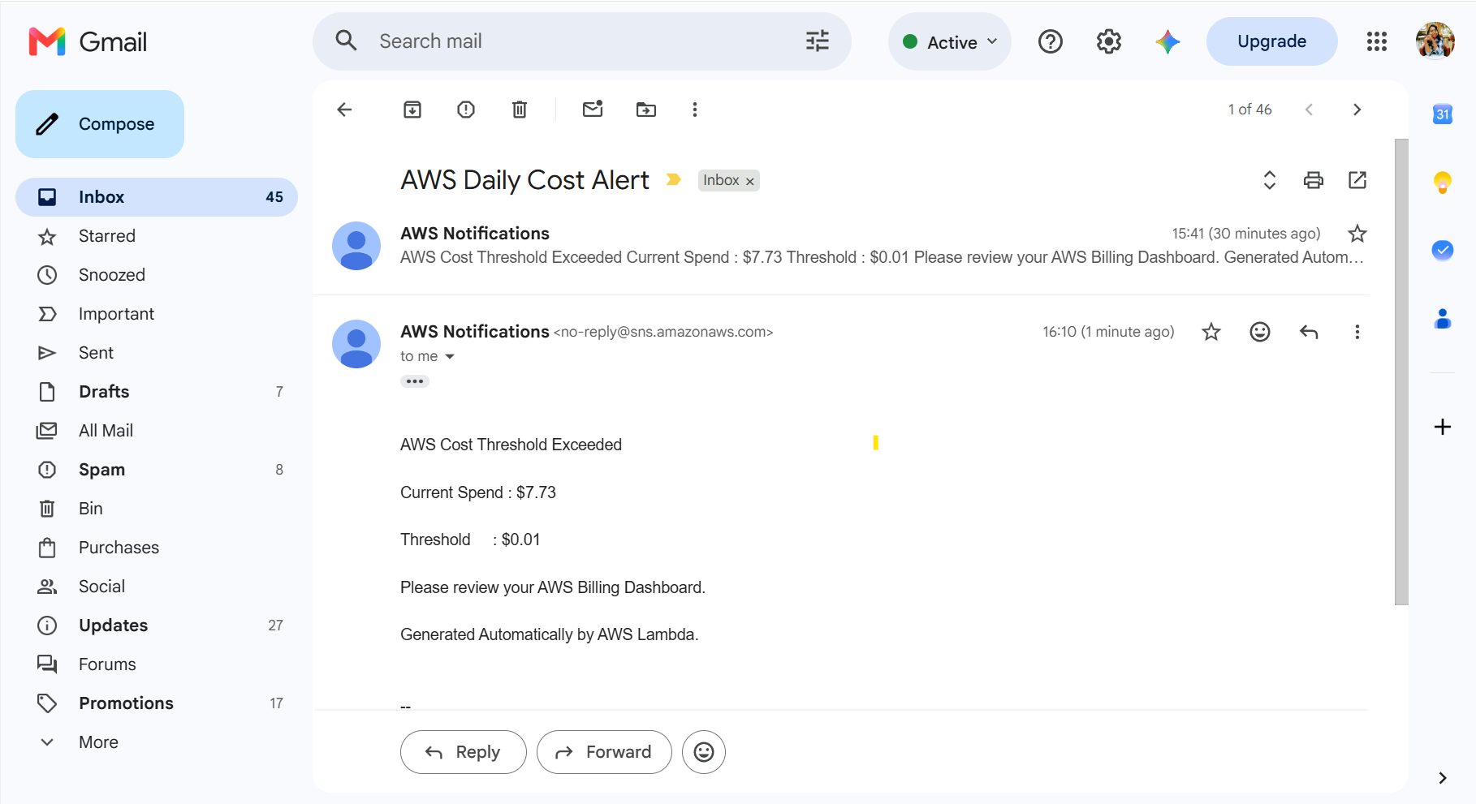

Step 12 – Create EventBridge Rule
Navigate to
Amazon EventBridge
→ Rules
→ Create Rule
Configuration
Setting | Value
Rule Name | DailyCostAlert
Rule Type | Schedule
Choose
Recurring Schedule
Cron Expression
cron(0 8 * * ? *)
Runs every day at 08:00 UTC.
Target
Lambda Function

DailyCostAlert
Create the rule.

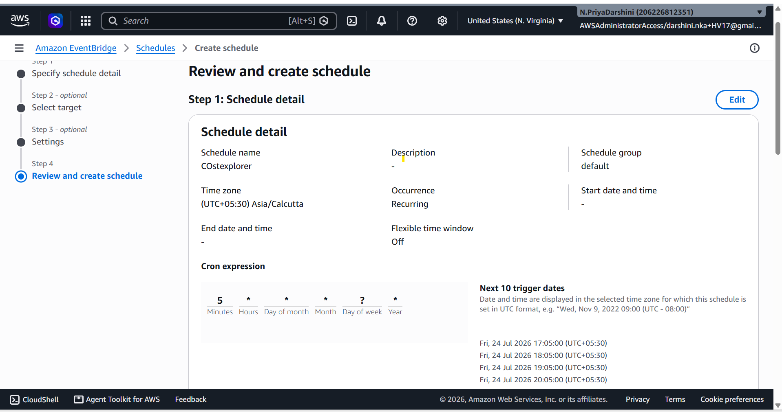

Step 13 – Verify CloudWatch Logs
Open
CloudWatch

→ Log Groups

→ /aws/lambda/DailyCostAlert
Example:
Current Month-to-Date Cost: $13.74

Alert sent successfully.

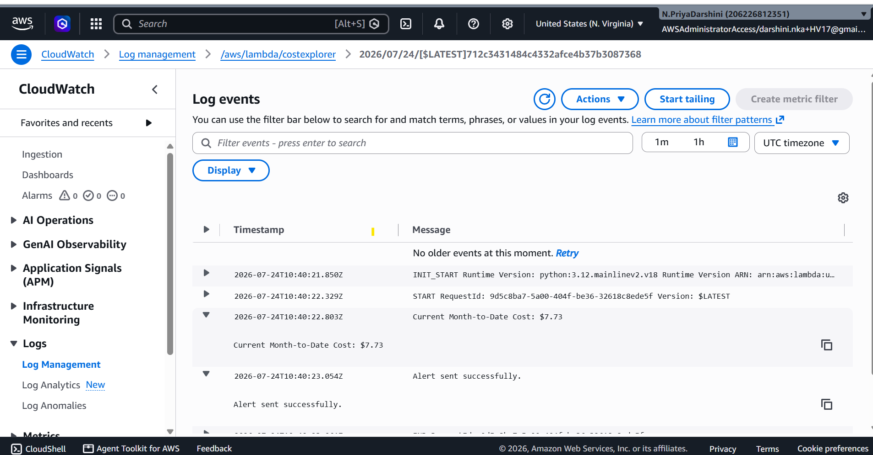

Sample Email
Subject
AWS Daily Cost Alert
Body
AWS Cost Threshold Exceeded

Current Spend : $13.74

Threshold : $10.00

Please review your AWS Billing Dashboard.

Generated Automatically by AWS Lambda.

Best Practices
- Use Lambda environment variables for the SNS topic ARN and cost threshold.
- Use least-privilege IAM by allowing sns:Publish only to your specific SNS topic.
- Add try/except blocks for better error handling in production.
- Monitor the Lambda with CloudWatch Logs and configure CloudWatch Alarms for failures.
- Extend the solution to send notifications to Slack or Microsoft Teams using AWS Chatbot or webhooks if needed.

Why not AWS Budgets?
AWS Budgets is the preferred managed service for simple cost threshold alerts because it provides built-in notifications, forecasting, and budget tracking without requiring custom code.
When is Lambda the better choice?
Lambda is a better choice when you need:
- Custom per-service, per-account, or per-tag cost analysis.
- Notifications to Slack, Microsoft Teams, or external systems.
- Cost anomaly detection with custom business rules.
- Integration with ticketing systems, databases, or dashboards.
- Advanced reporting or automated remediation based on cost data.

Why this version is the best
This implementation follows AWS best practices by using:
- Python 3.12
- Environment variables instead of hardcoded values
- Least-privilege IAM permissions
- Amazon EventBridge for scheduling
- Amazon SNS for notifications
- AWS Cost Explorer API (the current recommended approach)
- A structure that is suitable for production deployments and aligns well with common AWS certification and interview expectations.

*********************************END***************************************************

